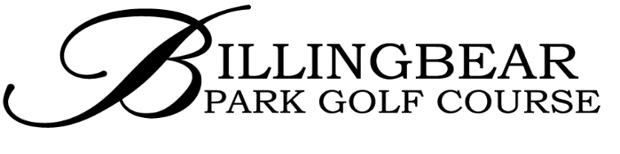
LOCAL RULES NOVEMBER 2019

Out of Bounds
Any area beyond the boundaries of the course are Out of Bounds and are marked by white posts. Rule 27
Internal out of bounds apply on holes 6, 7, 9, 15, 16 and 18 on the main course.

Fixed sprinkler heads and drain covers
Fixed sprinkler heads and drain covers are immovable obstructions and relief from interference may be taken under Rule 16.1

Penalty Areas
Penalty Areas are marked with red or yellow markers. Rule 17.

Protection of young trees.
If a player's ball lies anywhere on the course, other than a penalty area, and lies on or touches a staked of caged tree or the tree interferes with the player's stance or area of intended swing, the player may take relief under Rule 16.1f.

Exception:
This local rule will not apply for club competitions and rounds played for handicap purposes.

Temporary Immovable Obstructions

a)Watering reel or hose. Any player whose stroke strikes the watering reel or hose, may replay the shot from the same position without penalty, substituting another ball to do so if necessary.
Alternatively, the player may accept any deflection of the ball as a result of the original stroke as 'the rub of the green' and play his/her next shot from wherever the ball comes to rest.
A player's ball touching or lying close to the to the watering reel or hose in such a way as to cause interference to the player's stance, intended swing or line of play may be lifted cleaned and dropped without penalty, within one club length of the nearest point that avoids the interference but not nearer the hole under Rule 16.1a.

b) Posts, ropes and metal frames protecting approach to green
Any player whose shot strikes a rope, post or metal frame protecting the approach of any green, may replay the stroke from the original spot where the ball was played without penalty, substituting another ball to do so if necessary under Rule 16.1a
Alternatively, the golfer may accept any deflection of the ball as a result of the original stroke as 'the rub of the green' and play his/her next shot from where the ball comes to rest.

Movable Obstructions

Posts, ropes and metal frames protecting approach to green.
A player whose ball touches or lies close to posts. ropes or metal frames in that they interfere with the player's stance, intended swing or line of play but whose previous stroke did not strike a post, rope or frame, may temporarily move the post, rope or frame without penalty, to play the next stroke under Rule 15.2a.
.

Abnormal Course Conditions

a) Preferred Lies
Where a player's ball lies in part of the general area cut to fairway height or less, the player may take free relief once by placing the original ball or another ball within 6 inches or 15 cms of the original point at which the ball lay but not nearer the hole.
Relief from an embedded ball may be taken under Rule 16.3a

b) Aeration holes/drainage lines
If a player's ball lies in or touches an aeration hole:-
a) In the general area. The player may take relief under Rule 16.1b. If the ball comes to rest in another aeration hole the player may take relief again under this local rule.

b) On the Putting Green. The player may take relief under Rule 16.1d.Interference does not exist if the aeration hole only interferes with the player's stance or on the player's line of play.

Alternative to Stroke and Distance for Lost Ball or Ball Out of Bounds
When a player's ball has not been found or is known or virtually certain to be out of bounds, a player may take relief under penalty of two strokes, from the point at -
a) The Ball Reference Point. within two club lengths of where the original ball is estimated to have come to rest or crossed the out of bounds boundary or within two club lengths of a line from the hole through the reference point.
b) The Fairway Reference point. within two club lengths of the edge of the fairway nearest the ball reference point but not nearer the hole.

Exceptions:
a) This local rule will not apply for club competitions and rounds played for handicap purposes.
b) When the ball is known or virtually certain to have landed in a penalty area.
c) The player has played a provisional ball at penalty of stroke and distance (Rule 18.3) but may take relief for a provisional ball lost or out of bounds.

Distance measuring devices.
The use of distance measuring devices in competitions is allowed, except when they are designed to give additional information such as ground gradients, temperature or wind conditions, that might aid the user during play. Rule 4.3

Oct 2019

